Unique Identification Number__________________ (office use only)

Applicants details

Name
Address

Post Code
Date of Birth
Age
National Insurance Number
Unique Learner Number ULN*
*See end of form for privacy statement regarding use of ULN

Applicants contact details

Home phone number
Mobile number
Email address
Tell us the best way to contact you.

Next of kin contact details

Name
Relationship to applicant
Address (if different to applicants)
Email address
Emergency phone numbers | 1) | 2)

Referrer details (unless referring yourself!) e.g. social worker

Referrers name and job title
Contact number

Email address

Business address

Other professionals who know you (E.g. Social worker, Psychologist, previous manager etc.)

Name | Job title | Address and phone number
Please note we may contact these people for more information.

Benefits

Please tell us if you get any of these benefits | YES | NO
- Employment Support Allowance - ESA
- Personal Independence Payment - PIP
- Disability Living Allowance - DLA
- Job Seekers Allowance – JSA
- Incapacity Benefit
- Housing Benefit
- Universal Credit

Labour Market Status (LMS)

Use the flowchart to determine whether your Labour Market Status should be categorised as ‘Economically Inactive’ or ‘Unemployed’.

Then tick the appropriate box in the table below.

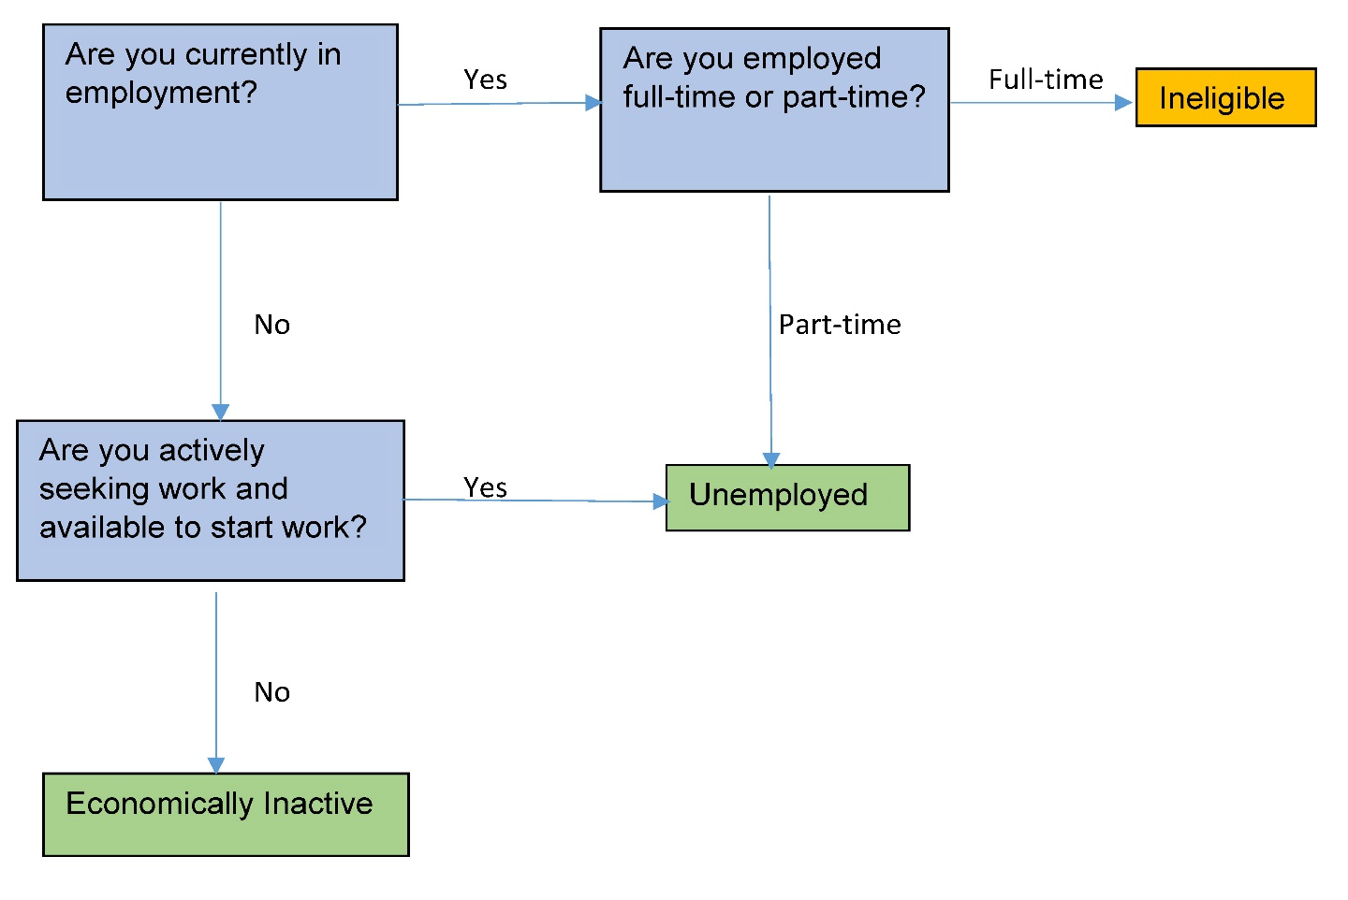
NB. Should you consider yourself as being employed ‘full time’, there are still circumstances in which you may be eligible to join the programme.
Please discuss this further with your contact at Orchardville to help determine your eligibility.

Yes | UNEMPLOYED Less than 6 months
Yes | UNEMPLOYED Between 6 and 12 months
Yes | UNEMPLOYED More than 12 months
No | ECONOMICALLY INACTIVE

Education - Please tick your highest level of qualification

Level | EC Levels | Please tick one only  your highest level
No Educational Attainment – No Education (formal of home schooling) | Primary & Lower Secondary
Foundation / Key stage 1 or 2 – Entry level diplomas, certificates and awards, essential skills at entry level

Key stage 3 - GCSE D-G or Level 1 awards/certificates/diplomas, Key Skills level 1, NVQ Level 1, Essential Skills level 1. Music grades 1 to 3

Key stage 4 - GCSE A*- C or Level 2 awards/certificates/diplomas, NVQ level 2, Essential Skills level 2, Intermediate apprenticeships, OCR Nationals, Music Grades 4 & 5 | Upper Secondary
Key stage 5 - A Level or AS Level pass, NVQ level 3, BTEC awards/certificates/diplomas, Advanced Apprenticeship, International Baccalaureate, Music Grades 6 to 8

Bachelor/Foundation degree/ NVQ4/ NVQ5/ HND – HNDs, NVQ’s level 4 & 5, Foundation Degree, Bachelor’s degree, Professional Graduate Certificate in Education, Diploma of Higher Education (DipHE), Degree apprenticeship, Graduate diplomas | Tertiary Educational
Studying towards Masters / Post Grad Diploma or Cert – Post Graduate Certificate in Education, postgraduate diplomas, certificates and awards
Master’s Degree/ Doctorate - Master’s degree, Doctoral Degree, BTEC Advanced professional diplomas, certificates and awards, Specialist diplomas, certificates and awards

Employment history – please include your CV if you have one.

Dates of employment | Employers name | Briefly describe your job and main duties | Paid (P) or Voluntary (V)

Your week currently

Tell us what a typical week looks like for you.

Monday | Tuesday | Wednesday | Thursday | Friday | Saturday

Other activities

Do you go to any other Health and Social Care Trust activities like a Day Centre or a club like ETC Club, Skyways, Junction Club, Portview, Bluebells or similar not mentioned above?

Do you attend any other employability service?

If yes, then tell us about it below.

How did you hear about us?

Orchardville Privacy Statement

What will we do with your information?
Any personal information you give us will be kept safe on our server and in locked filing cabinets. We also use Evide Impact Tracker and a European Social Fund database to hold information about you. We take the security and storage of your personal data very seriously and take every care to make sure it is safe with us.

We will only use your details for the legitimate purposes of Orchardville, to get to know you, to provide you with the right service and to meet the legal and contract requirements of our funders.

We will never sell your details or use them in any way that you would not reasonably expect. We will send you letters/emails and we will text or call you about things which directly relate to your service/activities at Orchardville. You will not receive marketing or other information from any third party.

Why do we need it?
We need this information:

- To register you onto our service
- To let our funders know who is using our service so they can create reports and understand what you have achieved on the project. This may also be shared with other government funding bodies
- To keep in contact with you, your family and/or support team.
- To provide you with the right services and appropriate support.

We have to share your details with our funders the European Social Fund (ESF), the European Commission and the Health and Social Care Trusts as part of our contracts with them. Personal data on participants will be shared with Special EU Programmes Body (SEUPB) for the purpose of identifying duplication between the Peace IV and the ESF programme. We will never share your details unnecessarily.

What information will we hold and how long will we keep it for?
We will hold the information you have provided in this application form and what you do when you leave the project until December 2030. This is for audit purposes. If you decide to leave the organisation we are still required to hold on to your information. Once this period is over we will destroy the documentation.

What are your rights?
- Individuals have the right to request a copy of the information we hold on computer and in some manual filing systems. This is known as the right of subject access.
- You have the right to have the data we keep on you deleted – if we are not legally required to keep it.
- You have the right to choose not to give us your data however that may restrict the services we provide.
- You have the right to expect that your data will be kept up to date and accurate.

Complaints – if you are unhappy with this privacy notice or how your personal information is handled please contact the Data Protection Officer at Orchardville. If you are unhappy with our response please contact the European Social Fund after that if you are still not happy, you should contact the Information Commissioners office.

Data Processor | Data Controller | Information Commissioners Office
Orchardville (FAO Data Protection Officer)  Lagan Village Tower  144-152 Ravenhill Road,  Belfast, BT6 8ED  02890 732 326 | European Social Fund,  Project Delivery Branch,  Dept. for the Economy,  Adelaide House,  39-49 Adelaide St. BT2 8ED  esf@economy-ni.gov.uk | Information Commissioners Office,  Wycliff House, Water Lane,  Wilmslow, Cheshire  SK9 5AF  03031231113  casework@ico.org.uk

Unique Learner Number – ULN
The government have issued the following privacy statement regarding the issuing of a ULN and the creation of a Personal Learning Record which will involve handling and storing of some personal information;
“The information you supply will be used by the Skills Funding Agency, an executive agency of the Department for Education (DfE), to issue you with a Unique Learner Number (ULN), and to create your Personal Learning Record. For more information about how your information is processed and shared refer to the Extended Privacy Notice available on Gov.UK.”

I am happy with the contents of this privacy notice; it has been explained to me and I have had any questions answered.

Applicant signature | Parent/Carer/Referrer  signature
Date | Date

PHOTOGRAPHIC CONSENT

Orchardville regularly uses photographs or videos of our service users for publicity purposes in annual reports, leaflets, magazines, on social media (such as Facebook and Twitter) or on our website.

We do this to show other people what it is like to come to Orchardville and also to celebrate the many successes of our service users.

We will not use your photograph or media image unless you tell us it’s okay - WE NEED YOUR PERMISSION. Please tell us below if you do or do not give us permission.

Please tick YES or NO to tell us if we can use your photograph | Tick
YES – you can use my photo

NO – you cannot use my photo

NB - We will check that you are still happy/unhappy for us to use your photo at your annual review each year. You may, however, change your mind at any time simply by informing either your employment officer or Louise Macrory - louise.macrory@orchardville.com.

Please return this application pack to:

Michael Walker or Kirsty Spencer
The Orchardville Society
Lagan Village Tower
144-152 Ravenhill Road
Belfast
BT6 8ED

Additional Information: Please feel free to add anything else you think we should know.

EQUAL OPPORTUNITIES MONITORING
REF NO:__________

THIS INFORMATION IS KEPT PRIVATE AND CONFIDENTIAL AT ALL TIMES.

WE WOULD BE GRATEFUL IF YOU COULD COMPLETE THIS FORM AND RETURN IT IN THE ENVELOPE PROVIDED.

SEX | TICK
- MALE

- FEMALE

RELIGIOUS BACKGROUND | TICK
- I AM A MEMBER OF THE PROTESTANT COMMUNITY

- I AM A MEMBER OF THE CATHOLIC COMMUNITY

- I AM A MEMBER OF NEITHER THE PROTESTANT NOR THE CATHOLIC COMMUNITY

ETHNIC IDENTITY | PLEASE CIRCLE
DO YOU CONSIDER YOURSELF AS HAVING AN ETHNIC MINORITY BACKGROUND? | YES  NO

ORCHARDVILLE RISK ASSESSMENT

Unique ID No.

So that we can provide the correct service and support, Orchardville staff are required to identify potential risk factors in order to put in place a risk management plan. To help us with this please TICK SECTION A where appropriate and provide as much detail as possible in SECTION B. If you have a copy of any of the following or similar, please include them;

- Epilepsy or diabetes management plan
- Psychology or Occupational Therapist reports
- Health and Social Care Trust risk assessments
- Speech and Language assessments

SECTION A; has the above person experienced any challenges within the following areas over the last 5 years?

RISK FACTORS | YES | NO
Verbal aggression
Physical Aggression
Sexually Inappropriate
Criminal Conviction/cautions
Self-Injurious Behaviour
History of Theft
Adult Safeguarding Concerns
Epilepsy
Diabetes
Heart Conditions
Respiratory conditions
Mobility
Mental Health (anxiety, phobias, OCD, depression etc.)
Allergies
Other (please specify e.g. other health diagnosis, known tendency to wander/get lost)

SECTION B:

If you ticked YES to ANY of the above please provide detailed information below.

Risk Factor | Information: Please include how often incidents occur, circumstances, triggers, management of behaviour, medication taken etc.
 | Continue on another page if necessary

Medication

Do you take any medication? | Please circle - Yes / No
If you circled ‘yes’ can you tell us what the medication is, what it’s for and if you can take it yourself

Disability Information

Do you have a diagnosis of; | Tick Yes | Tick No
Learning Disability
Autism
Both – Autism and a learning disability
Neither – please give more details

Annex A

Pro-forma for Self-Declaration of Disability

(To be completed by the participant or a proxy of the participant)

Organisation: Orchardville

Project Name: Ignite2

Participant Name:

DOB:

I certify that I have/ or (insert name of participant) has a disability (as defined by
the Disability Discrimination Act 1995) which has a substantial and long-term
adverse effect on my/their ability to carry out normal day-to-day activities.

Signed: ____________________

Dated: ____________________

